Acceptance Testing

bugFamily_outputs.txt

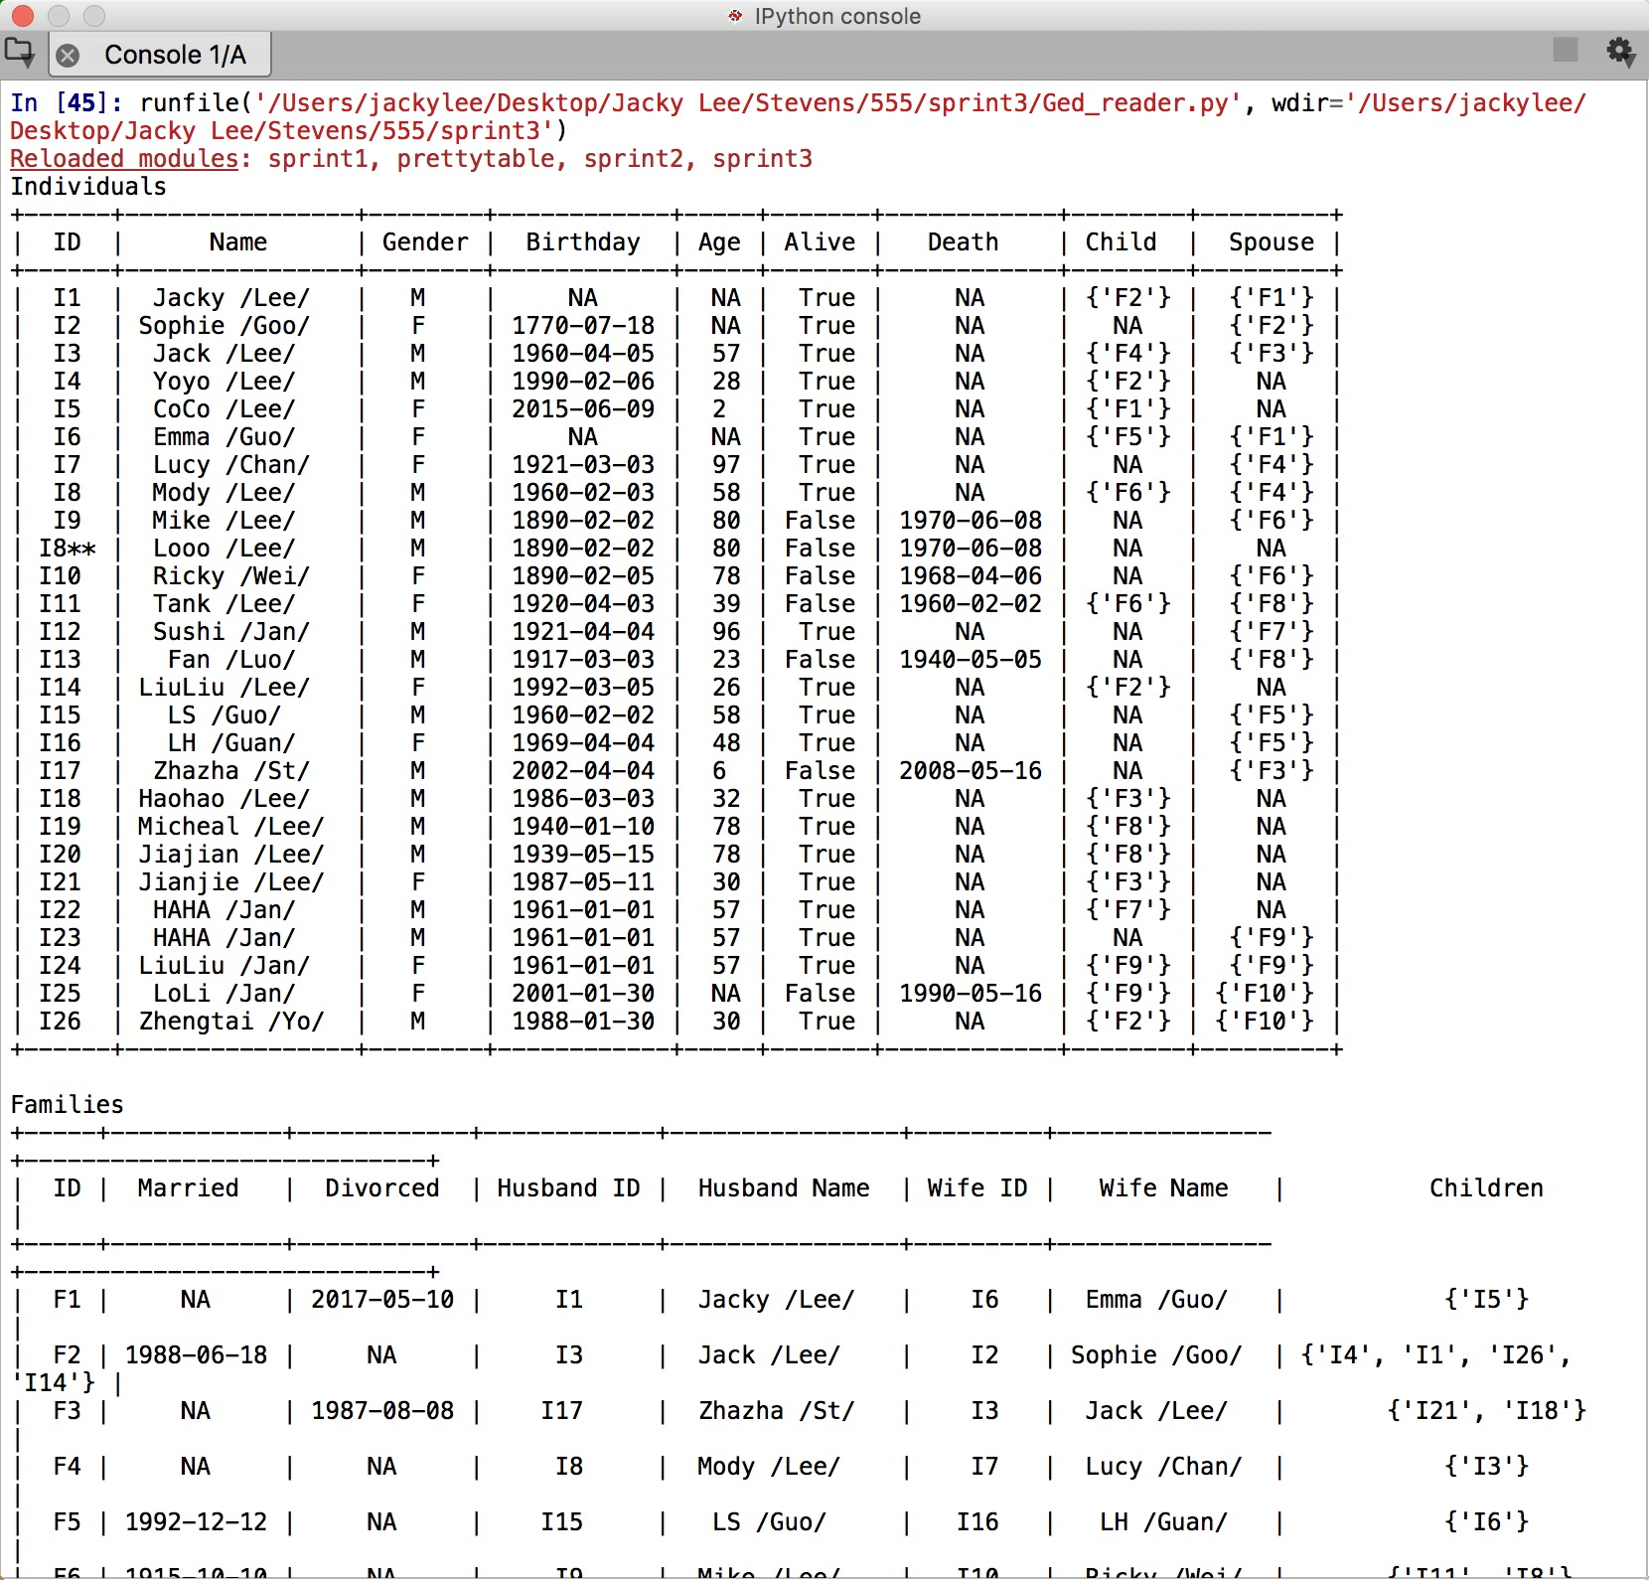

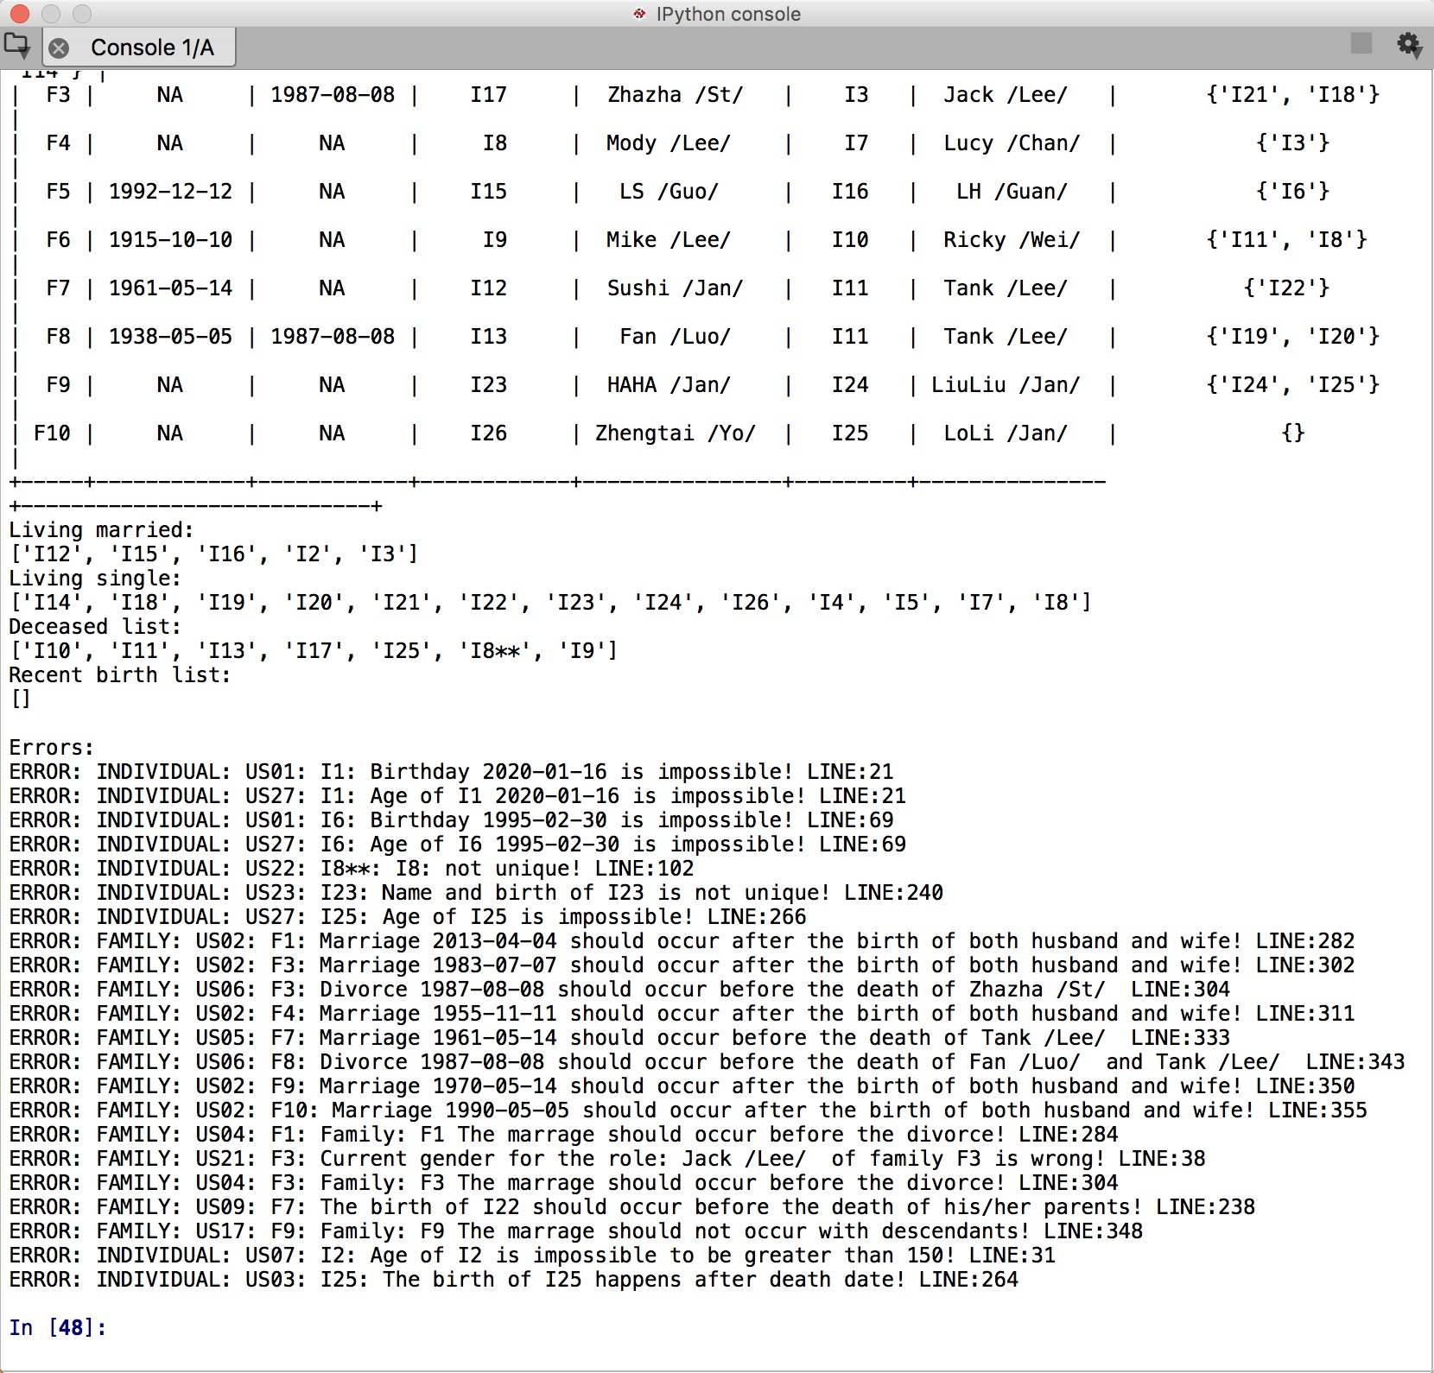



Sprint1:

US01:

I1 Jacky Lee’s birthday is 2020-01-16 which is in the future.

I6 Emma Guo’s birthday is 1995-02-30 which is impossible.

For correct data, we did not print errors.

US02:

In F1, the marriage occurred before the birth of the husband.

In F3, the marriage occurred before the birth of the wife.

In F4, the marriage occurred before the birth of the husband.

In F9, the marriage occurred before the birth of both the husband and the wife.

For correct data, we did not print errors.

US09:

In F7, the birth of I22 was 1961-01-01 which occurred after the death of Tank Lee 1960-02-02. It was impossible.

For correct data, we did not print errors.

US21:

In F3, the gender of both husband and wife are male. It is impossible.

For correct data, we did not print errors.

US22:

For I8 Looo Lee, his ID is not unique and same as Mody Lee.

For correct data, we did not print errors.

US27:

For I1, his age is unable to calculate.

For I6, his birthday is impossible so his age is also unable to calculate.

Other people’s ages are correct.

Sprint 2:

US04

In F1 and F3, the marriage occurred after the divorce which is impossible.

For correct data, we did not print errors.

US06

In F8, the divorce should happen before the death of both the husband and the wife,

For correct data, we did not print errors.

US07

For I2, the age is larger than 150 which should be impossible.

For correct data, we did not print errors.

US17

In F9, the marriage should not occur with descendant who is the wife.

For correct data, we did not print errors.

US23

For I23, the name and birth of Haha Jan was same as I22, which should be impossible.

For correct data, we did not print errors.

US40

For each error, the line number was shown at the end of the error and was same as the input file.

Sprint3:

US03:

For I25, the birth happens after the death date, which should be impossible.

For correct data, we did not print errors.

US05:

For F7, the marriage of 1961-05-14 occurs after the death of Tank Lee which should be impossible.

For correct data, we did not print errors.

Family_outputs.txt

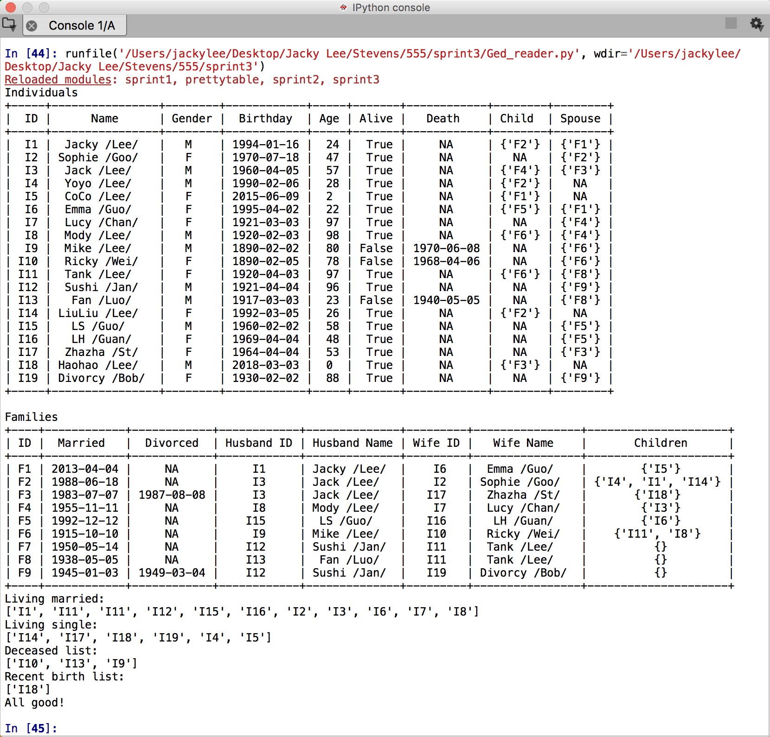

For correct file and data, we did not print any error.

US29:

Deceased members are listed in the in the result.

US30:

Living married members are listed in the in the result.

US31:

Living single members are listed in the in the result.

US37:

Members who is born recently are listed in the in the result.